 SUBMITTED BY: ZULQARNAIN HAIDER
REG #: SP24-BSE-179
SUBJECT: Data Structure Lab 1
SUBMITTED TO: Nauman khan
DATE: 03-09-2025
____________________________________________________________
Calculator:
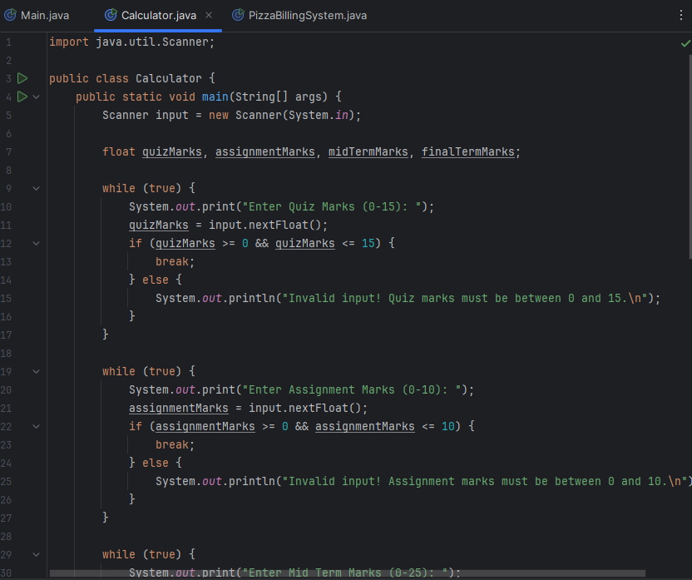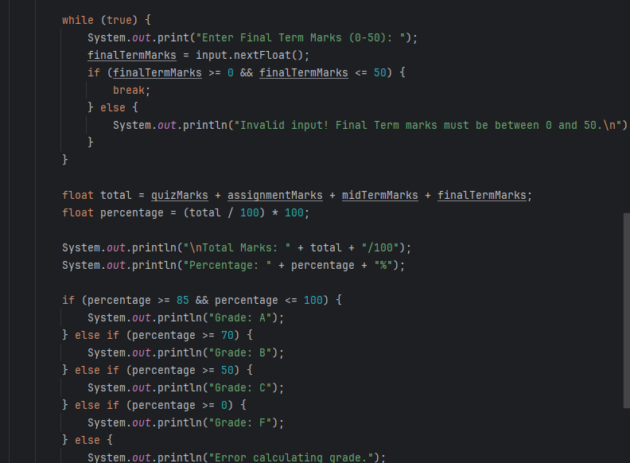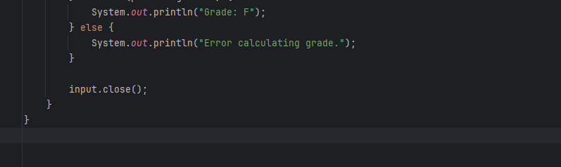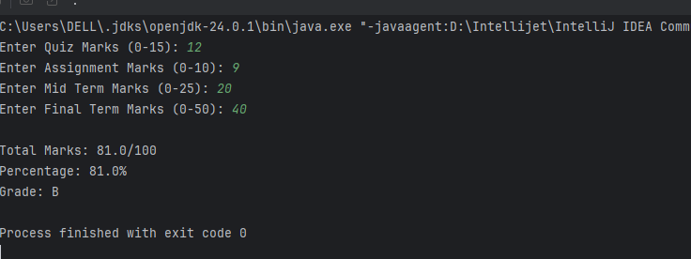
Pizza Billing System:
